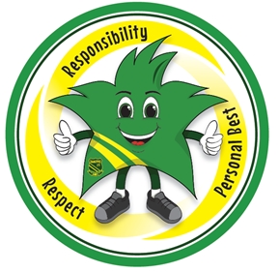

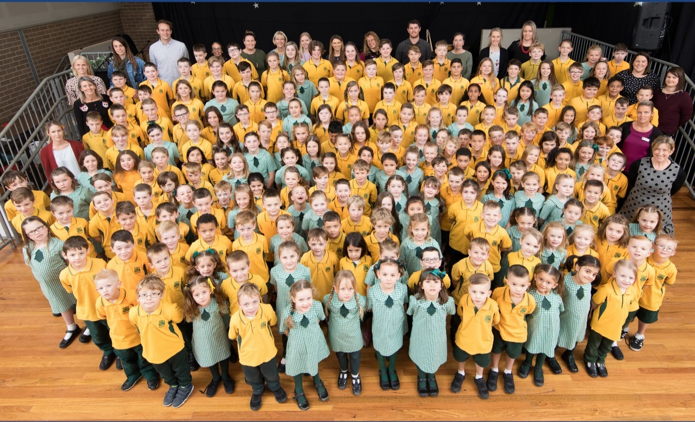
Garden Suburb Public School
School Information Booklet
2020
CONTENTS

 |  | Page Number
Welcome/General Information |  | 3
School History |  | 4
Term Dates for 2020 |  | 5
School Routines | Arrival, Bell Times, Lunch, Dismissal | 6
School Security | Late arrivals, early pick ups, lunch/recess pickups, access to school grounds, leaving grounds & sick students | 7
School Administration | Absences, school sport, excursions, consent forms, transportation of students. | 8
Communicating with our Community | Skoolbag, school newsletters, Webpage, Facebook & Interviews | 10
Transport | Parking and bus passes | 11
Health | Medication in school, student special needs, immunisation certificate & sun protection | 12
General | Lost property, book packs, OOSH, school banking | 13
Canteen | Healthy school strategy | 13
School Uniform | Uniform, Sport’s house, clothing pool & uniform orders | 14
School Song |  | 15

Welcome to
GARDEN SUBURB PUBLIC SCHOOL
A caring environment providing quality education
Address: | Prospect Road, Garden Suburb NSW 2289
Telephone: | (02) 4943 4898
Fax: | (02) 4942 1552
E-mail: | gardensub-p.school@det.nsw.edu.au
Website: | www.gardensub-p.schools.nsw.edu.au
School Hours: | 8.45 am | Morning Play Bell
 | 9.10 am | Class
 | 11.10 am | Lunch
 | 12.00 pm | Return to Class
 | 2.00 pm | Recess
 | 2.25 pm | Return to Class
 | 3.10 pm | End of the school day
Principal: | Mrs Louise Dunn
Assistant Principals: | Mrs Jennifer Samuels  Mrs Elle Cooper
Administration Staff: | Mrs Melissa Mills – School Administration Manager  Mrs Catherine Edwards – School Administration Officer  Mrs Nicole Skewes – School Administration Officer Wednesday  Mrs Laura Steward – School Administration Officer Thursday

SCHOOL HISTORY
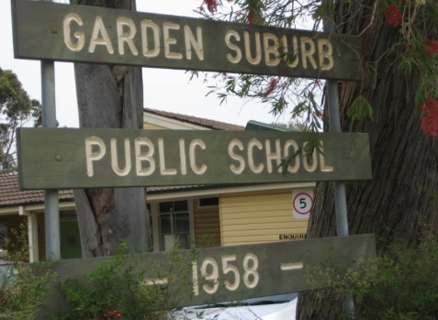
Garden Suburb Public School opened for business on Monday October 13th, 1958 with an enrolment of 125 students. The buildings comprised four classrooms, office and ablutions block (toilets).

However the story begins some years earlier before that date.

Local parents and the Garden Suburb Progress Association worked hard to establish the need for a school in the suburb. Many of these people still live in the area. It took eight years to have the land released from BHP.

Approval to build the school was given on September 27th 1957, then to be named Kotara Heights. The name was altered to Garden Suburb on June 26th 1958, just prior to the arrival of Mr Howard Smith, the first Principal, who was appointed in July of that year.

The school grew rapidly. The Methodist Church hall (across the road) was used as a classroom. Even then the small library was being used as a classroom. Tenders were called for two additional classrooms, a clinic and a storeroom.

The official opening was October 29th, 1960. The Hon Mr J Stewart MLA, officiated. By this time the enrolment had more than doubled with 282 students. Mr Rundle was the Principal with a staff of 6 teachers. The average class size was 40 students.

The wooden building near Myall Road was completed in 1961 and in 1965 a brick block was added. 1970 saw the completion of another block and canteen.

In 1992 major alteration converted 2 classrooms beside the office to create a staffroom and enlarged office space.

The new Millennium has brought the addition of the COLA (Covered Outdoor Learning Area), the installation of fixed play equipment – with soft safe underlay, air conditioning in classrooms, staffroom and offices, covered walkways and a multi-purpose court.

In 2008, the school celebrated its 50th year with a School Musical and Fete.

In 2008-2009, the existing computer lab was enlarged and upgraded and interactive whiteboards were installed in every classroom. The library was enlarged and enhanced. Thanks to the Federal Governments BER program the school received a new hall which was opened in 2010, this being a great addition to the school.

In 2019 the school converted an existing space into a technology hub where students can engage in technology lessons, STEM activities and robotics lessons.

TERM DATES FOR 2020

Term 1 | Teachers Commence | Tuesday, 28th January 2020
 | Best Start Assessments | Wednesday, 29th January 2020
 | Best Start Assessments | Thursday, 30th January 2020
 | Best Start Assessments | Friday, 31st January 2020
 | Year 1 to Year 6 Commence Classes  Kindergarten Commence Class | Wednesday, 29th January 2020  Monday 3rd February 2020
 | Last Day Term 1 | Thursday, 9th April 2020
Term 2 | Teachers Commence | Monday, 27th April 2020
 | Students Commence Classes | Tuesday, 28th April 2020
 | Last Day Term 2 | Friday, 3rd July 2020
Term 3 | Teachers Commence | Monday, 20th July 2020
 | Students Commence Classes | Tuesday, 21st July 2020
 | Last Day Term 3 | Friday, 25th September 2020
Term 4 | Teachers and Students Commence Classes | Monday, 12th October 2020
 | Students last day Term 4 | Wednesday, 16th December 2020
 | Staff Development Day | Thursday, 17th December 2020
 | Staff Development Day | Friday, 18th December 2020

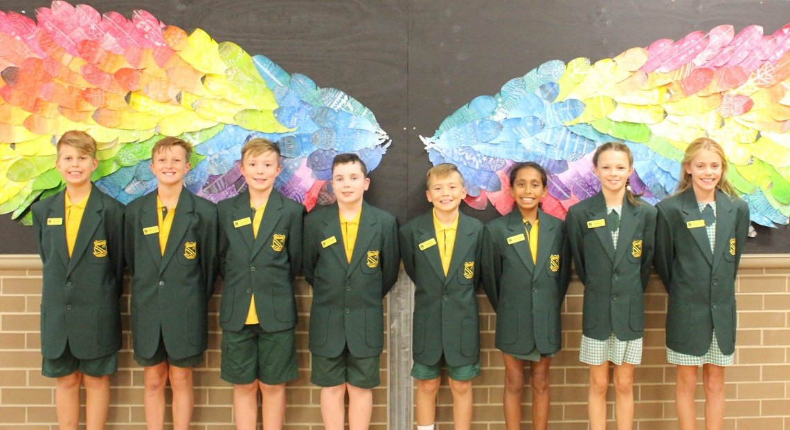

SCHOOL ROUTINES

Arrival
It is requested that children do not arrive at school before 8.45am. Official supervision commences at 8.45am. Children who do arrive before 8.45am are to sit in the COLA until the bell goes when they may move to the “top” playground or play under the COLA. Children are not to play or use any equipment, be it personal or school equipment, before 8.45am.

Bell Times
8.45am | Children may move to the playground
9.07am | Play ceases children move to lines
9.10am | Lessons commence
11.10am | Lunch (supervised eating time)
11.20am | Play
11.57am | Play ceases children move to lines
12.00pm | Lessons commence
2.00pm | Recess
2.23pm | Play ceases children move to lines
2.25pm | Lessons commence
3.10pm | Afternoon Dismissal

Children are supervised crossing Prospect Road by Crossing Guards who are managed by Roads and Maritime Services.
During inclement weather children are supervised in the classrooms before school.

Lunch
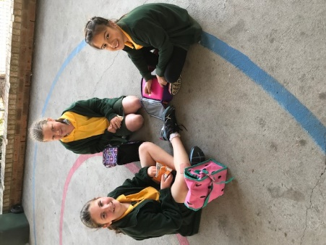
Lunch is eaten outside under the supervision of teachers. Students are then dismissed by teachers to the playground for the rest of lunch. Any child who forgets their lunch, or forgets to order their lunch, should report to a staff member, who will then ask the office to make a basic sandwich or contact parents.

Dismissal
Following the 3.10pm bell, children assemble at either of the gates opening on to Prospect Road or the gate leading onto Myall Road. Students are encouraged to leave school and go straight home. Students are not permitted to play in any part of the playground after the bell.

Front gate on Prospect Road
This gate is used by all children who walk along Prospect Road, all children catching the OOSH bus and students using the pedestrian crossing which is supervised by Crossing Supervisors. All students catching the OOSH bus must wait on the verandah and the on duty teacher will take them out to the bus.

Gate onto Myall Road
Students who walk down Myall Road enter and exit the school via this gate.

Gate on Progress Place
Students who walk down Progress Place use this gate.

Please remind your child to collect all bags and clothing before leaving school.

SCHOOL SECURITY

Late Arrivals
- Students must present at the office where the student will be signed in. Students will receive a late note that is to be given to the class teacher.
- Students will say goodbye to their parents/carers here and will forward onto class. If needed a class buddy will be called to the office to accompany the student to class.

Early Pick Up
- Parents and carers are to come to the office where the student will be signed out.
- The office will call the classroom and have the student sent up to the office with their bag.

Lunch/Recess Pick Ups
- Parents and carers are to come to the office where the student will be signed out.
- The school will use the PA system during these times to notify the student and staff on duty. The teacher on duty will have keys to the classrooms and will open the classroom to have the students’ bag collected to go home.
- Students will then take their bag and meet their parent or carer at the front office.

Parents are not to approach classrooms during class time as this is often very disruptive to the class and the lessons taking place.

Access to school grounds
All parents/carers and visitors must access the school via the office outside of drop and pick up times. You will be asked to sign in and directed to your appointment destination.

Leaving Grounds
In the interest of safety, children are not permitted to leave the school grounds at any time without written permission of a parent and being signed out at the office

Sick Students
When, in the opinion of school staff, a student’s best interest would be served by being at home, the parents or emergency contact will be telephoned and requested to take home the sick student. It is therefore essential that we have current phone numbers for contacting you.

SCHOOL ADMINISTRATION

Attendance (Department of Education)
Section 22 of the Education Act (1990) states that it is the duty of the parent of a child of compulsory school-age to cause the child:
(a) to be enrolled at, and to attend, a government school or a registered non-government school, or
(b) to be registered for home schooling with the NSW Education Standards Authority (NESA) and to receive instruction in accordance with the conditions to which the registration is subject.
All students who are enrolled at school, regardless of their age, are expected to attend that school whenever instruction is provided.

Absences
The Department of Education and Communities requires that you notify the school if your child is going to be absent for two days or more. A note of explanation should then be sent to the teacher when the child returns so that the reason for the absence can be recorded in the class roll. Alternatively, you can send an absence notification through the Skoolbag app or contact the office who will complete a verbal absence form explaining your child’s absence. If you chose these options, there is no need to send a note to the teacher. All roles will be marked by 9.30am and any students that are identified as absent without a reason, parents will be called to obtain a reason and ensure the safety of the student.

School Sport
All children participate in sport on Friday. All children should wear sports uniform on this day. An annual Swimming Carnival (8 years and above), Athletics Carnival and Cross Country Carnival are held and some children take part in PSSA competitions.
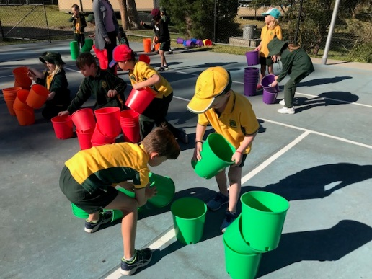
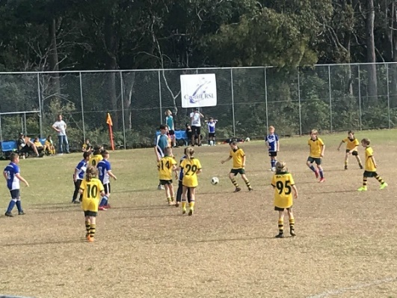
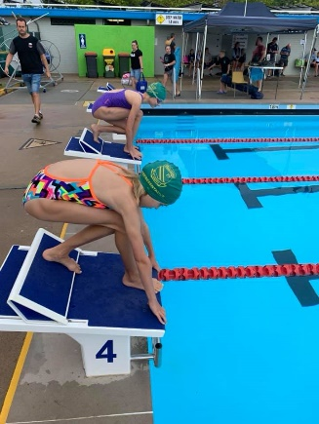

Excursions
Educational excursions are an integral part of the school’s curriculum as they provide the opportunity for children to participate in experiences in the wider community. These experiences beyond the classroom contribute to the child’s overall growth and development.

Excursions will vary in length depending on the age of the children and may range between
- A brief visit of less than an hour to a local point of interest
- An excursion of a full day’s duration
- A major excursion occupying a number of days and requiring overnight accommodation.

Excursions, which currently form part of the school’s curriculum at Garden Suburb, are:
- Part or full day excursions depending on particular units of work being treated by the class, e.g. to the Regional Museum or to the Cardiff shops
- 3day/2night excursion in alternate years to Great Aussie Bush Camp for Stage 2 students.
- 3day/2night excursion in alternate years to Canberra for Stage 3 students.

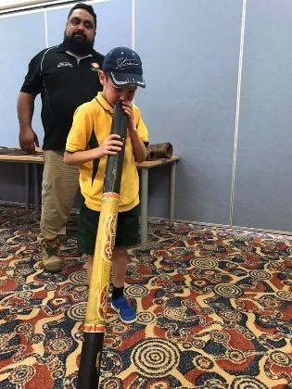
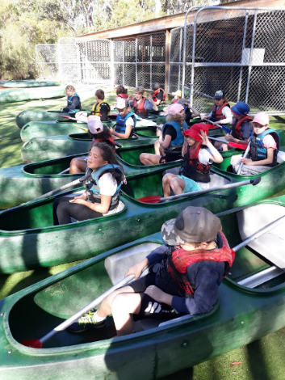
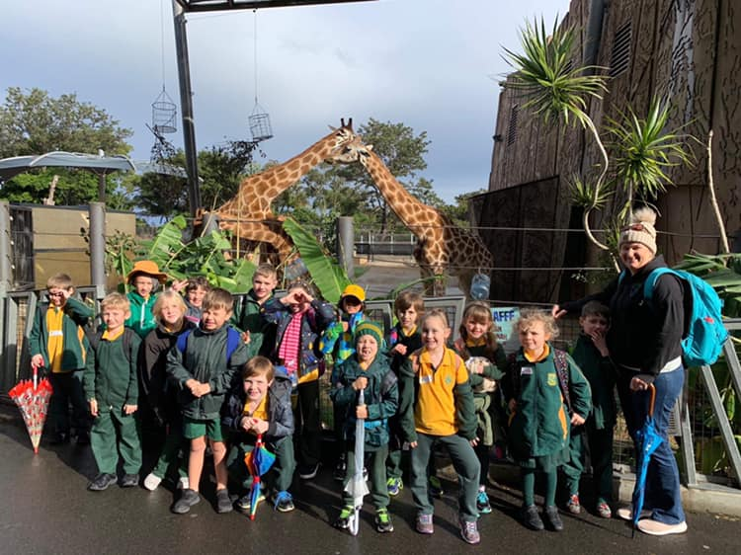

School uniform should be worn unless otherwise specified. Excursion consent forms must be returned to school. As children are ambassadors for our school whilst on excursions, appropriate behaviour is expected.

Consent Forms
Before students undertake excursions, sporting visits etc. they are required to return a consent note signed by a parent or guardian. This consent note will confirm the parent’s knowledge and approval of their child undertaking the visit. A general consent note is given out early in the year which covers activities/excursions in the local area which do not require any transport or extra supervision. Additional yearly notes include Technology.

Transportation of Students
Some school excursions and inter school activities depend on parent transport as bus hire is not viable. If you are able to help with transportation of school students, other than your own children, then your current NSW licence, NSW registration and Full comprehensive insurance are required to be presented to the office along with a completed Appendix 5. Drivers must provide a Working With Children Check (WWCC) number and each student must use an approved seat belt while travelling.

Students will not be permitted to be transported in vehicles that are not able to provide the relevant documentation even when they have permission from their own parents.

COMMUNICATING WITH OUR COMMUNITY

Skoolbag App
Our school has our own Skoolbag iPhone and Android App to help us communicate more effectively with our parent community. By installing the app you will be able to receive the school newsletter, inform the school of a student’s absence or change of details e.g. contact phone numbers.

We ask parents to install our Skoolbag School App. To install it, just search for our school name “Garden Suburb Public School” in either the Apple App Store, or Google Play Store.

School Newsletters
The school newsletter is the prime source of communication with our community. It is available on our Skoolbag App and school website. You can also organise with the office to have a paper copy sent home.

As well as informing you of all that is happening in our school, it provides information about community events.

School Webpage
Our school webpage at www.gardensub-p.schools.nsw.edu.au has a wealth of information about schools from the Department and has all classes and school information.

School Facebook page
The school has a Facebook page where you can find information about what is happening each week, student successes and community information.
Our school Facebook page can be found by searching ‘Garden Suburb Public School’ on Facebook.

Interviews
Formal parent/teacher conferences will be conducted during Semester 1 when each child’s progress is reported upon. An invitation is extended to parents to visit the school at any time throughout the year if you have any concerns but we request that you make an appointment convenient to you and your child’s teacher so as not to interrupt teaching and learning time. The parent/teacher partnership is a critical one in your child’s education. If you are wishing to make an appointment with your child’s teacher please contact the office.

Parent Information Sessions
Parents/carers will be invited to a class information session early in Term 1 (usually Week 4) to meet the teacher and learn more about classroom routines and expectations. More information will be sent out at the beginning of the year.

TRANSPORT

Parking
Parking in the vicinity of the school is not permitted under any circumstances.

Parents are requested to obey traffic signs and road rules at all times. Incorrect parking creates an accident prone environment. Police and council inspectors patrol these areas regularly. A section of Prospect Road near the school is zoned a school crossing area with appropriate signs.

Bus Passes
Free bus passes are available to all students if the distance from their home to school is more than 1.6km or the walking distance from home to school is 2.3km or further. Applications can be made online https://apps.transport.nsw.gov.au/ssts.

HEALTH

Medication in Schools
If your child requires medication on a regular or short term basis you must visit the office to leave the medication and complete a request to administer prescribed medication form. The school is unable to administer over the counter medication e.g. Paracetamol, Nurofen.

Parents/carers who wish their child to self-medicate (e.g. Asthma puffer) must complete a written request document.

If approved the Principal will provide a letter to parents/carers confirming any arrangements. The school's decision to support any parental request for a student to self-administer prescribed medication will be influenced by the following:
- the ability and maturity level of the student
- relevant parental and medical advice
- the complexity of the administration of prescribed medication procedure
- the willingness of the student to self-administer
- the level of support required in an emergency

Student Special Needs
Please inform the school in writing of any special needs which your child(ren) may have e.g. allergies, reactions to certain foods etc. Please advise the school of a management plan.

Immunisation Certificate
From 1 April 2018, all school principals are required to request an immunisation certificate at enrolment. Immunisation is a simple, safe and effective way of protecting the community and individuals from disease. All children enrolling in kindergarten are required to provide an Australian Immunisation Register “Immunisation History Statement” to the school.

Sun Protection
It is school policy for a school hat to be worn in the playground. Children without a hat must play under the COLA. School hats are available from the uniform shop. Sun screen and insect repellent should be applied before school. Sunscreen is available at school should students need to reapply. If students need a specific type of sunscreen they can supply their own.

GENERAL

Lost Property
Lost property is placed in the lost property basket in the COLA. Items not eventually claimed are absorbed into the clothing pool.

Children’s clothing and property should be clearly marked with the child’s name for easy identification and return.

Book Packs
In 2019 the school did not ask for Voluntary School Contributions but for each child to purchase a book pack. Contents of the book pack vary each year. The 2020 book pack fee will be $50. Invoices will be sent out early in Term 1 2020.

Out of School Hours Care (OOSH)
There are two OOSH’s that service the school. Students are dropped off in the morning and picked up in the afternoon by buses. For further information contact Cardiff OOSH (Cardiff Public School grounds) on 4956 8814 or Hillsborough OOSH (Hillsborough Public School Grounds) on 4947 8370. Students leaving school on the OOSH bus meet on the verandah near the office each afternoon.

School Banking
The School offers CommBank’s School Banking on Friday mornings before school starts in the library. Please see the volunteers for more information.

CANTEEN

In 2019 canteen facilities are available from Tuesday to Friday. Sound, nutritious foods are sold including sandwiches, hot foods and snack foods, all at very reasonable prices. Children are asked to place their order, with money enclosed, in a paper bag then place into a class basket/tub, which is collected from and delivered to each classroom. The canteen is only open at lunch time.

Healthy School Canteen Strategy
The Healthy School Canteen Strategy promotes healthy food and drink choices for all students in NSW. As a Premier’s priority, all schools in NSW must meet the Food and Drink Criteria by the end of December 2019.

Healthy eating is important as it provides students with the essential energy and nutrients they need to learn, play and grow. Children need to eat healthier foods and drinks to meet their recommended requirements. Healthy habits for life are set up in childhood – overweight children are more likely to go on to become overweight or obese adults with an increased risk of serious chronic health problems.

SCHOOL UNIFORM

Wearing of the correct school uniform is an indicator of the students pride in their school and is an agreed item of our Wellbeing Policy.
Please mark all belongings with your child’s name and ensure that your child is dressed in correct school uniform.
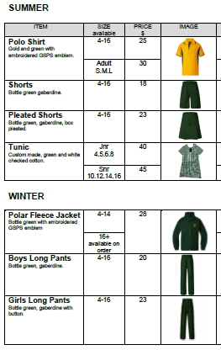
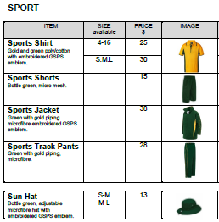

Sport’s House Uniform
Normal sports uniform for boys and girls. House coloured t-shirts may be worn at swimming and athletics carnivals. House colours will be announced prior to the first carnival of the year.

Kendall: RED | Lawson: BLUE | Paterson: GREEN

Clothing Pool
A second hand clothing pool is available as part of the Uniform Shop for your convenience. Items may be either donated or purchased (for a small amount). In 2019 the Uniform Shop is open on Thursday mornings from 8.45am to 9.30am. The Uniform Shop is the room next to the Office.

Uniform Orders
The P&C coordinates orders of polo shirts, girls summer uniforms, boys and girls school shorts and sport shirts/shorts throughout the year. Details are sent home in the newsletter and given to new Kindergarten parents. The school also supplies the hat and library bags.

GARDEN SUBURB PUBLIC SCHOOL
SCHOOL SONG
(to the tune of “Waltzing Matilda”)

Garden Suburb Primary
School we are proud of
Playing and learning together are we.
On the field and in the classroom
Teachers and neighbours
Teach us pride in community.

CHORUS
Garden Suburb, Garden Suburb
Looking towards the future are we
As we learn the value of friendship and unity
We are Australians young and free.

Here with our school friends
We work together
All of us equal, we all belong.
Learning and growing
Proudly knowing that
Our school will ring with laughter and song.
CHORUS

